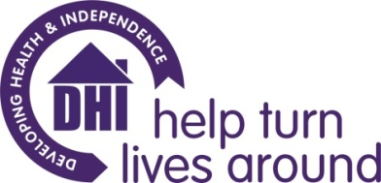

DHI Counselling Service information for prospective placement/volunteer counsellors

- DHI provides free, short term counselling in the BANES & South Gloucestershire areas to support clients experiencing substance misuse

- DHI also provides free, short term counselling in the BANES, Bristol & South Gloucestershire areas to support family members & carers affected by their loved one’s substance misuse.

- DHI is commissioned to provide solution focused counselling underpinned by person-centred qualities & values to support clients in achieving their stated goals.

- DHI clients are offered six, weekly, 50 minute sessions with the potential for some additional sessions subject to clinical supervisor & line management approval. DHI Clients can request to access the counselling service on more than one occasion.

- DHI provides individual clinical supervision twice per month (totalling two equivalent hours per month) via Zoom/phone. DHI also provides regular line management, support from our Volunteers Team and training opportunities.

- DHI provides a mobile phone for counsellors to arrange client appointments.

- DHI provides the opportunity for counsellors to attend in-house training days on Motivational Interviewing, Solution Focused Brief Therapy & Relapse Prevention.

- Counsellors are required to have completed & passed a minimum of 1 years counselling training (which included counselling skills practice with peers) & be undertaking/due to undertake or have completed further counselling training. This training should include person centred/humanistic counselling as a core model. DHI counselling placements are unsuitable for trainees/volunteers wishing to practice a psychodynamic approach.

- Counsellors are required to record brief counselling appointment attendance information on DHI’s electronic client database.

- Counsellors are required to adhere to relevant DHI policies including safeguarding adults, child protection & data protection.

- Counsellors are expected to work within BACP (or equivalent professional body) ethical framework guidelines.

