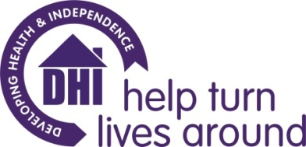

DHI Counselling Service information for prospective placement/volunteer counsellors

- DHI provides free, short term counselling in the BANES & South Gloucestershire areas to support clients experiencing substance misuse

- DHI also provides free, short term counselling in the BANES, Bristol & South Gloucestershire areas to support family members & carers affected by their loved one’s substance misuse.

- DHI is commissioned to provide solution focused counselling underpinned by person-centred qualities & values to support clients in achieving their stated goals.

- DHI clients are offered six, weekly, 50 minute sessions with the potential for some additional sessions subject to clinical supervisor & line management approval. DHI Clients can request to access the counselling service on more than one occasion.

- DHI provides individual clinical supervision twice per month (totalling two equivalent hours per month) via Zoom or phone. DHI also provides regular line management, support from our Volunteers Team and training opportunities.

- DHI provides a mobile phone for counsellors to arrange client appointments.

- DHI provides the opportunity for counsellors to attend in-house training days on Motivational Interviewing, Solution Focused Brief Therapy & Relapse Prevention.

- Counsellors are required to have completed & passed a minimum of 1 years counselling training (which included counselling skills practice with peers) & be undertaking/due to undertake or have completed further counselling training. Alternatively you may apply if you have completed 2 terms of initial counselling training and have supporting reference of competency from your training provider tutor. This training should include person centred/humanistic counselling as a core model. DHI counselling placements are unsuitable for trainees/volunteers wishing to practice a psychodynamic approach.

- Counsellors are required to record brief counselling appointment attendance information on DHI’s electronic client database.

- Counsellors are required to adhere to relevant DHI policies including safeguarding adults, child protection & data protection.

- Counsellors are expected to work within BACP (or equivalent professional body) ethical framework guidelines.

