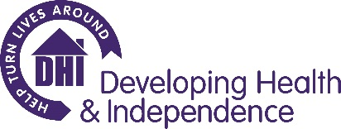

Promoting Equality, Diversity and Inclusion

Equality, diversity and inclusion is a core belief of Developing Health & Independence (DHI). All staff who work for DHI have a strong commitment to treating everyone fairly, challenging inequalities and promoting and advancing opportunities for all by ensuring that equality of opportunity is integral to our policies and working practices. We aim to create conditions where every individual is treated with respect and dignity, where everyone has the right to equal and fair treatment and can engage and contribute.

DHI aims to ensure that no job applicant, staff member, volunteer or organisation or individual to whom we provide services, will be discriminated against on any grounds including:

Age, Disability, Gender Re-assignment, Marriage and Civil Partnership Status, Pregnancy or Maternity, Race, Religion or Belief, Sex or Sexual Orientation, or Political Belief, Class, Caring Responsibility, Employment Status, Trade Union Membership or Unrelated Criminal Conviction.

In order to monitor how effective our equality and diversity policies are being implemented we ask all those applying for roles to complete an equality and diversity questionnaire.

Information collected is used in aggregate only and has no impact on recruitment decisions.

We would be grateful if you would complete the following.

Sex | Choose an item.
Sexual Orientation | Choose an item.
Gender | Choose an item.
Marital Status | Choose an item.
Age | Choose an item.
Ethnicity | Choose an item.
Religious Belief | Choose an item.
Are you pregnant or have a child under six months old? | Choose an item.
Do you consider yourself disabled? | Choose an item.

Information collected is used in aggregate only and has no impact on recruitment decisions.

When complete please email to hr@dhi-services.org.uk in complete confidence.

